The White Helmets Club

**Website Requirements**

# **Home Page:**

· Tagline (or) good sentence for club - 2 lines

Observe. Contribute. Change.

· about club - 4 lines

The White Helmets is a social outreach club made of a group of compassionate people who are dedicated to improving the lives of underprivileged people in the community. We work tirelessly to provide support and resources to the people struggling to make ends meet. In addition to that, we recognize the potential of small businesses and aim to provide them with the necessary tools to succeed. We try to serve as a reminder that even small acts of kindness make a big difference in the world.

· about college - 4 lines

VIT boasts of a highly experienced and dedicated faculty, state-of-the-art facilities and a rigorous academic schedule which prepares its students for the rapidly developing industry. VIT helps students gain real-world experience and an exposure to cutting-edge technology. Students are encouraged to participate in a wide range of extra-curricular activities, including sports, cultural events and technical competitions. The institute believes in the importance of a well rounded education paired with a focus on co-curricular activities which in turn helps prepare the students for the real world.

· Observe, Contribute, change - each 1 line definition

**Observe:** Observe ‘WHAT IS’ with undivided awareness.

**Contribute:**It is not what we get or who we become, it is what we contribute that gives meaning to our lives.

**Change:** The people who are crazy enough to think they can change the world are the ones who do.

· Testimonial -> 5 persons - name, statement, contact links

· abstract about club - 2 lines

# **Events Page**

· about club events - 2 line short description (general)

The White Helmets club aims to organize fun events which create awareness about societal issues. We believe in action more than words and the events have always proved the enthusiasm we have towards working for society.

· events name

· photo of each event - 1each

· each event description - 4 to 5 lines

1. Capture

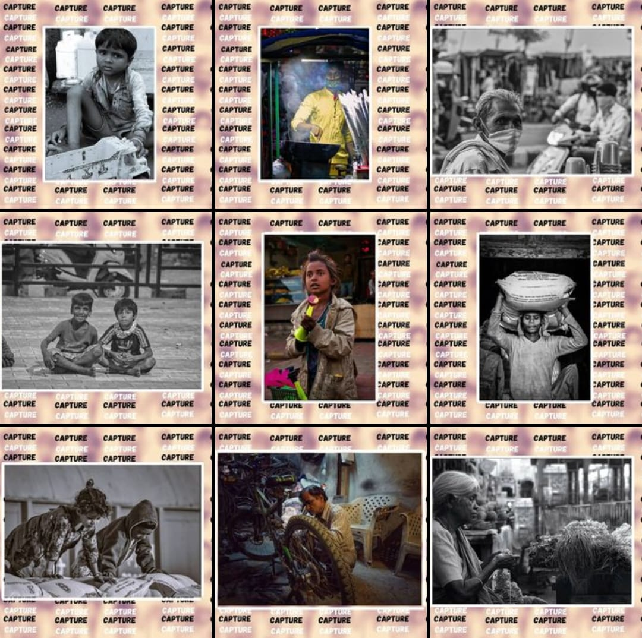

With The White Helmets' first event, we asked participants to CAPTURE a photograph on the theme of “Working Class Labours”. This event aimed to raise awareness and foster empathy toward the struggles of working-class laborers. By showcasing these evocative photographs, we aspired to create a platform for dialogue and understanding. The working class laborers form the backbone of our communities, yet their struggles often go unnoticed. By amplifying their voices we can shed light on the systemic challenges they face every day. By capturing their stories, we can inspire empathy, prompt action, and work towards creating a more equitable and supportive environment for all. We went on to have Capture 2.0 to continue this legacy.

1. Sociothon

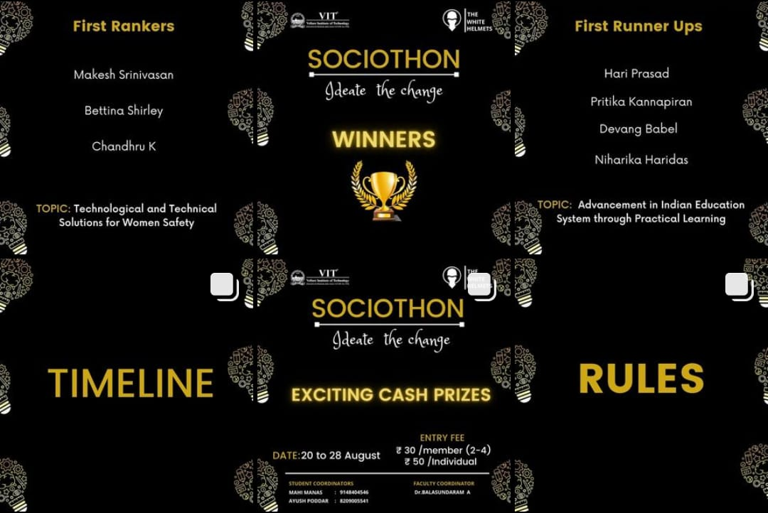

Sociothon was an engaging event that challenged its participants to tackle pressing social welfare issues by coming up with creative and innovative solutions themselves. By encouraging participants to think deeply about these issues, we aimed to foster a culture of innovation and empower change-makers who are passionate about creating a positive impact in their communities. Participants had to select their problem statement and engage in a thoughtful process of research, analysis, and solution development. Through presentations, they had the opportunity to articulate their ideas, proposed strategies, and potential outcomes.

1. CharEaty

The White Helmet collaborated with the Indian Association for the Blind to bring a heartwarming charity drive to our campus that aimed to promote and support the incredible work of blind workers. Our primary goal was to raise awareness and provide meaningful support to the association. The drive was a testament to the power of unity and collective action. By coming together as a community, we created a significant impact on the lives of blind workers. We went on to have CharEaty 2.0 to contribute to this cause further.

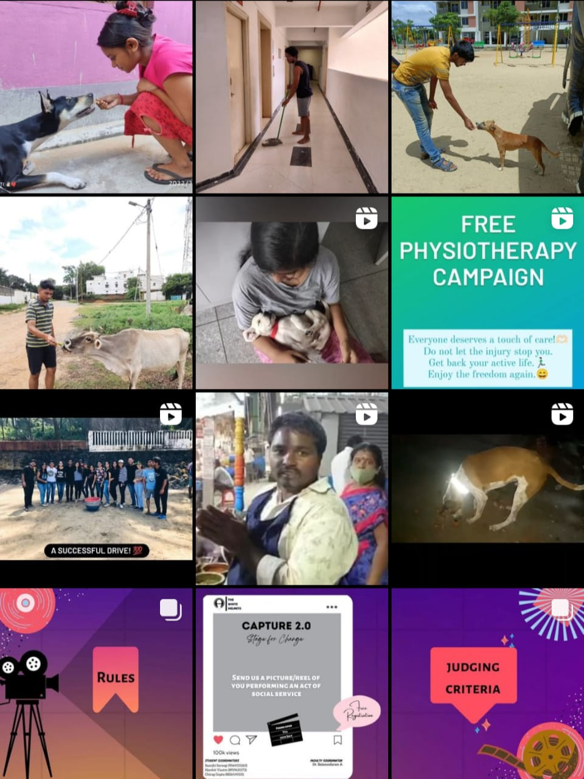

1. Talent Hunt

The White Helmets hosted an exhilarating event that celebrated the diverse talents and abilities of individuals. The participants were given the opportunity to showcase their unique skills in front of an enthusiastic audience. By encouraging participation and creating a lively atmosphere, we aimed to cultivate a supportive community that appreciates and celebrates the diverse range of skills and abilities within our society.

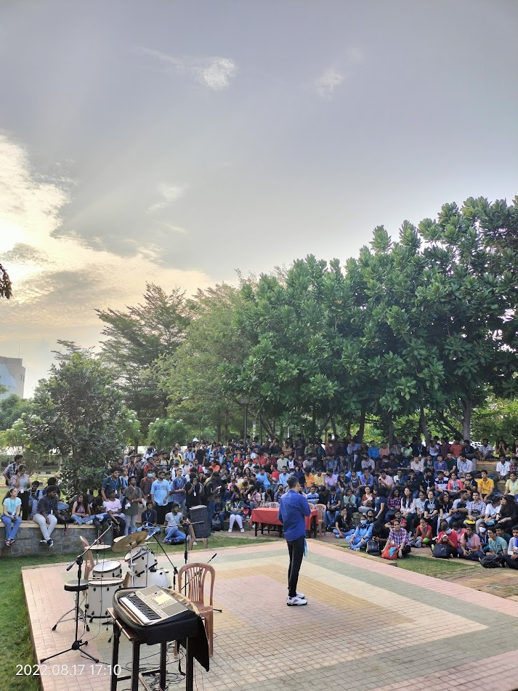

1. CharEaty 2.0

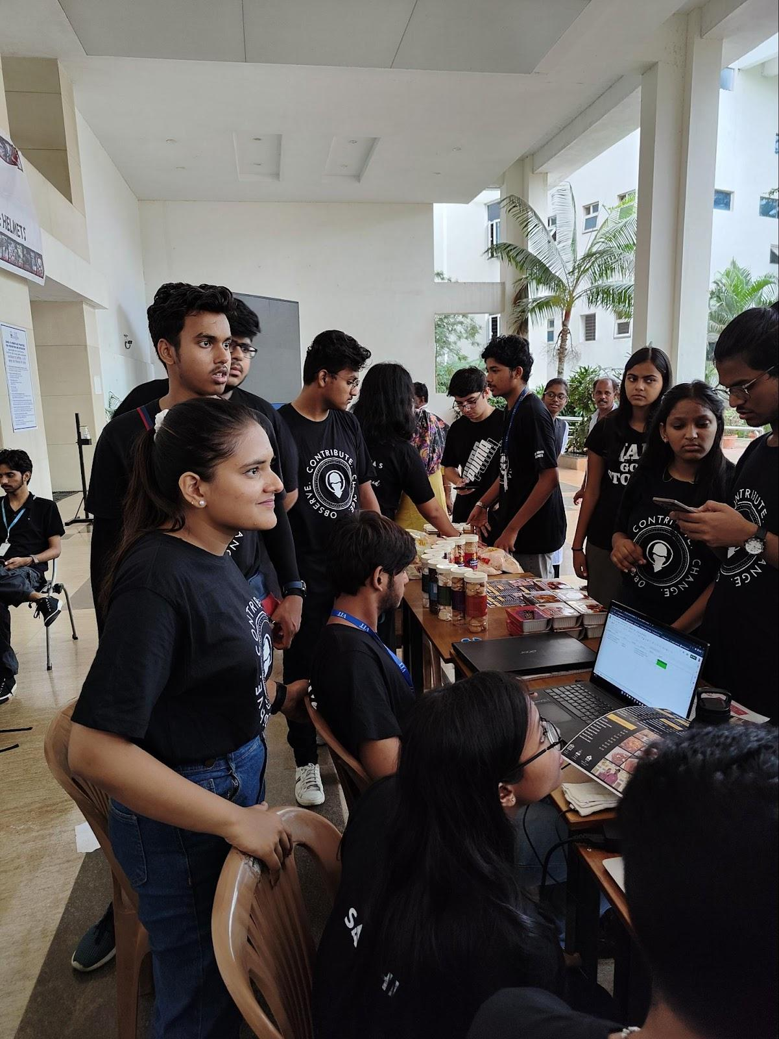

1. Project Sangam

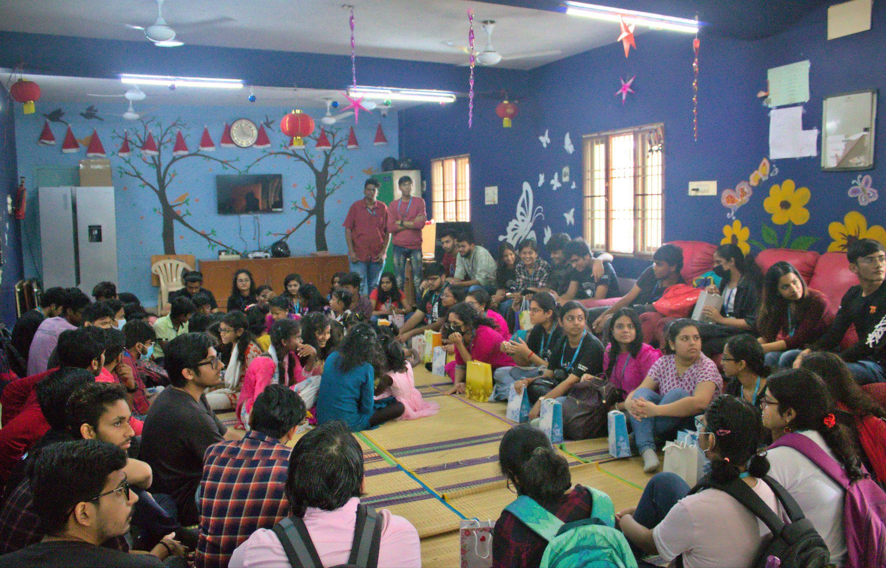

The White Helmet proudly hosted Project Sangam where we collected donations from fellow students on our college campus and donated them to a non-profit organization dedicated to supporting children with AIDS and other incurable diseases. We visited the NGO to engage in fun activities with the kids, playing and dancing with them, as we strive to uplift their spirits and learn about their hardships. This event aims to bring smiles, support, and awareness to the lives of these extraordinary children.

Children fighting against AIDS and incurable diseases deserve care, support, and happiness in their lives. This event served as an opportunity to contribute to their well-being by providing them with essential resources through donations. Additionally, by spending time with these children, we gained insights into their experiences, shared moments of joy, and fostered understanding and compassion within our college community.

# **Department page**

· about club departments - 2 line short description (general)

· All coordinates name & role

· photo

· description of them (or) words by them

· Social media links – 3 max - (in google form)

1. President - Arnab Nayak

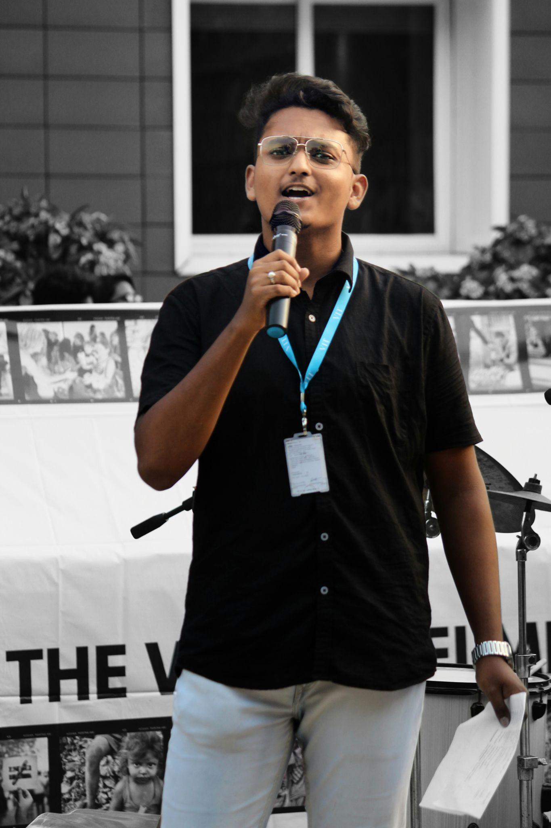

“Edify integrity. Seek excellence. Strive for perfection.”

1. Vice President - Manas Choudhary

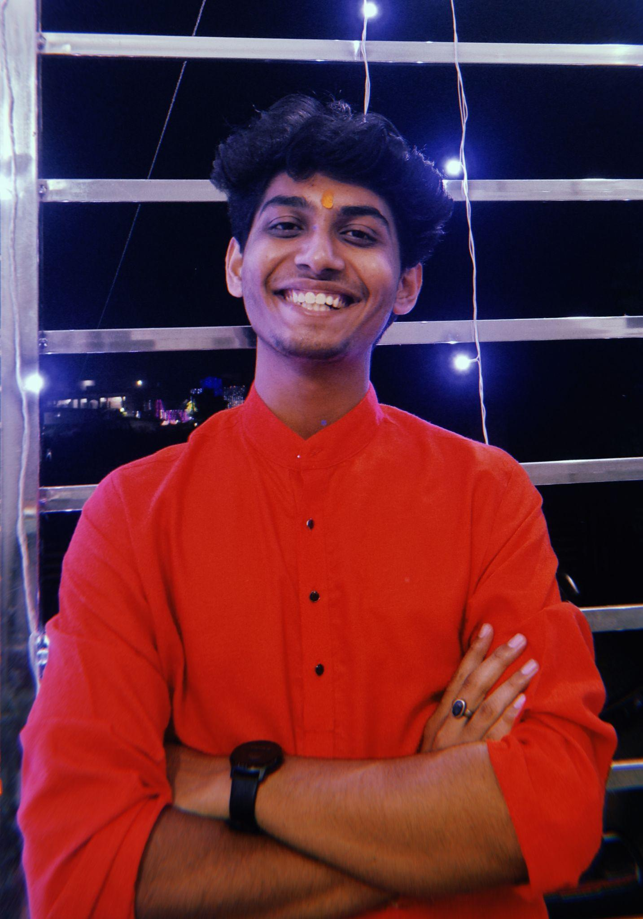

“Influencing and empowering others and inspiring trust and confidence.”

1. General Secretary - Shradha Suman Jena

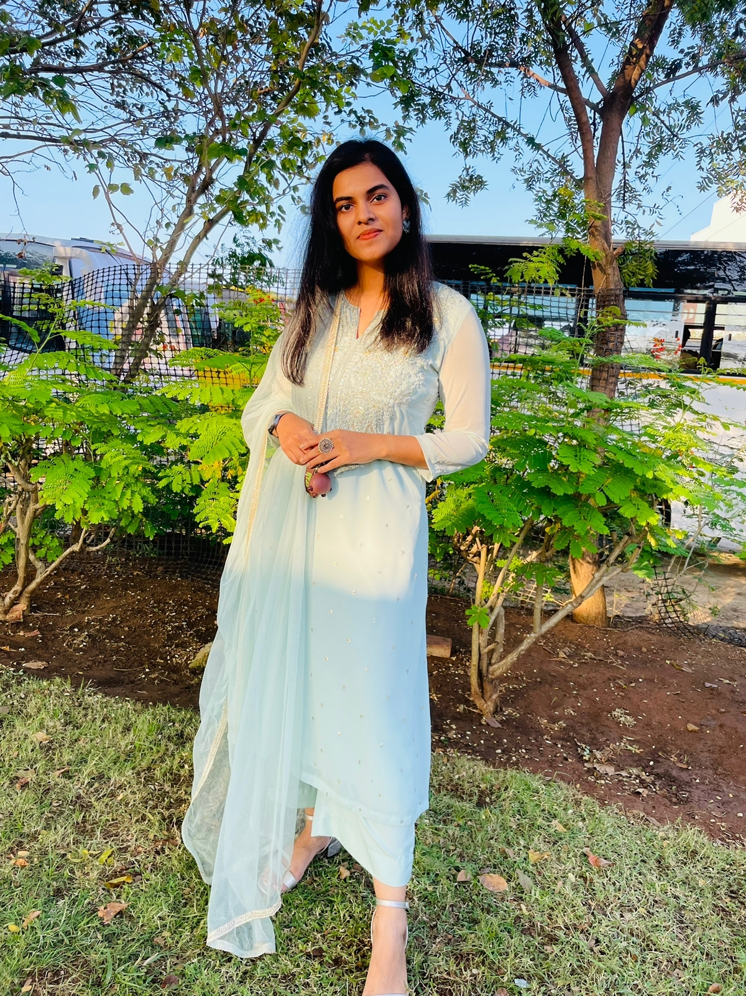

“Always ready to wrap the teammates with respect, dedication and passion to make us better.”

1. Marketing and Management

Tanmay Bopache

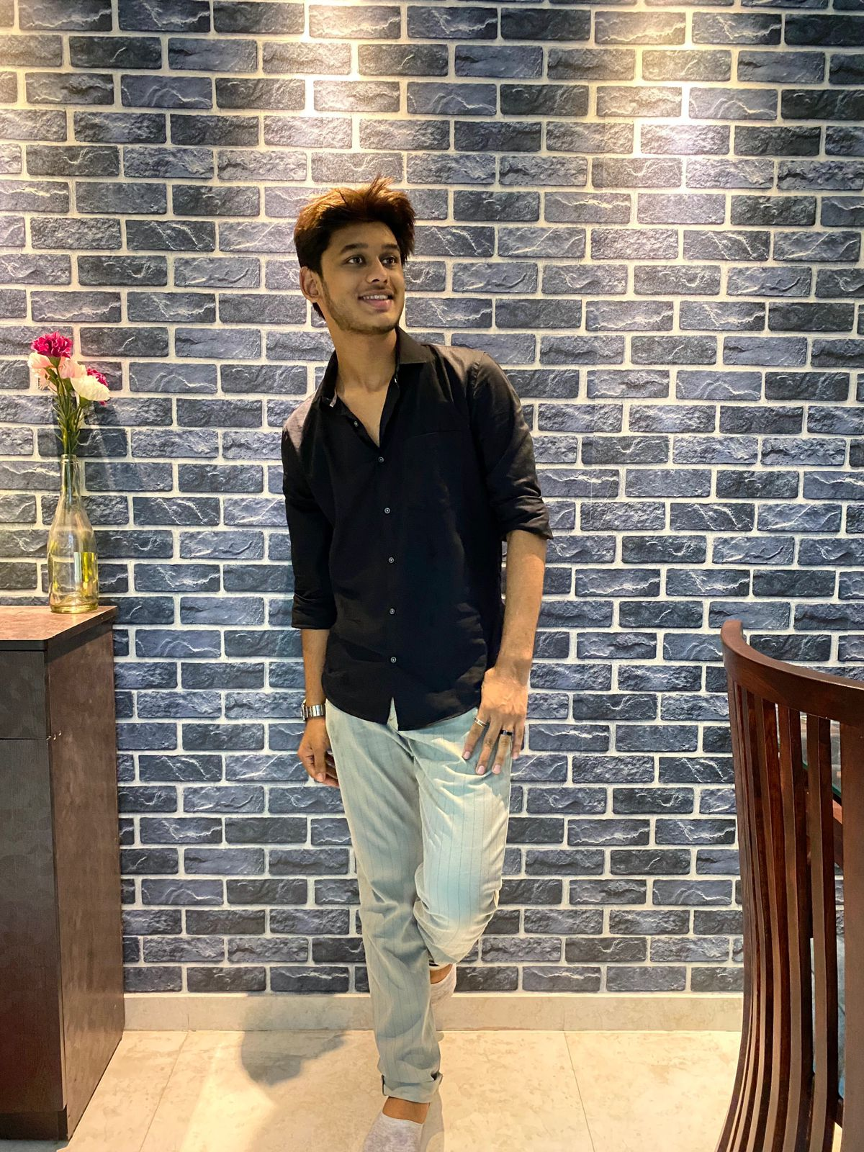

“Successful marketing is not about being first, it's about being different.”

Aditi Srivastava

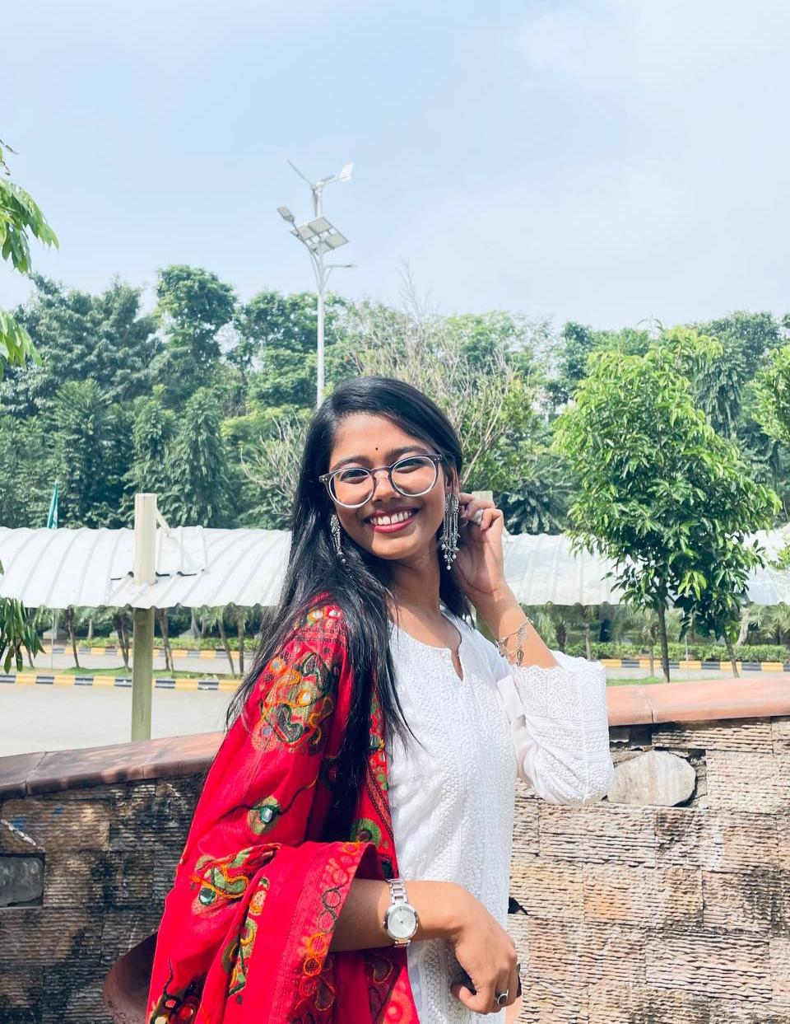

“If you want to RUN the DAY before the DAY RUNS you, make management your obsession.”

**Design**

Ashna Sachdeva

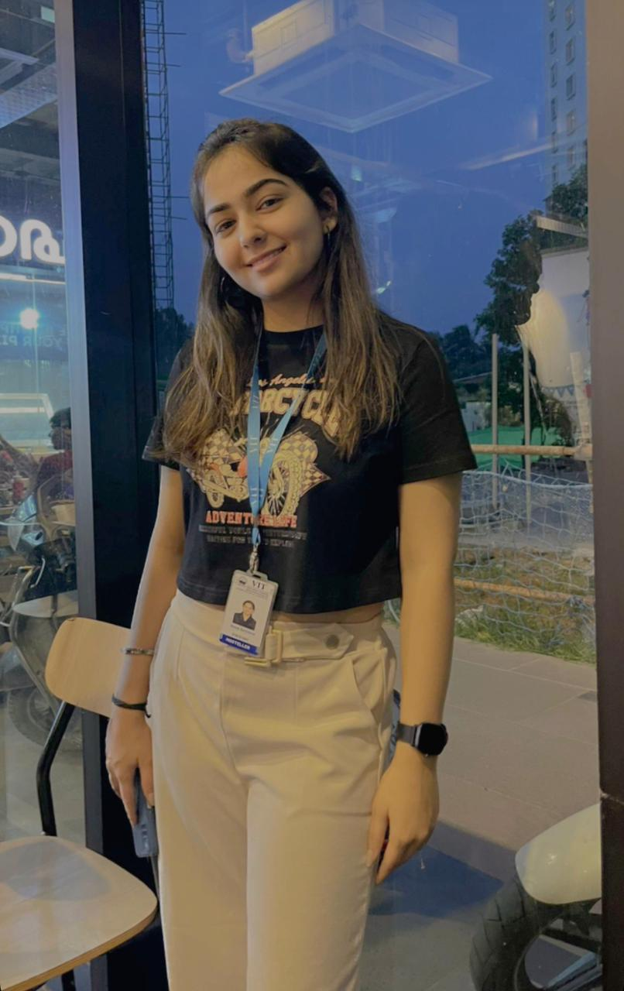

“Every great design begins with an even better story.”

Kashish Rajbhar

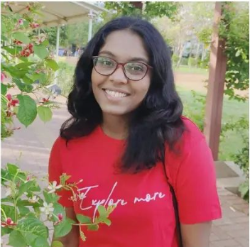

“Styles come and go. Good design is a language, not a style.”

**Content**

Abinaya

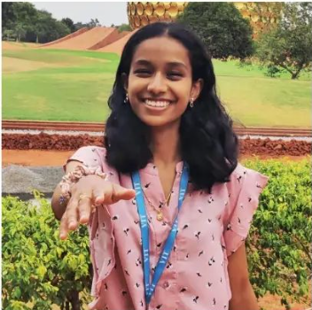

“Good content isn't about storytelling. It’s about telling a true story well.”

Shinjini Paul

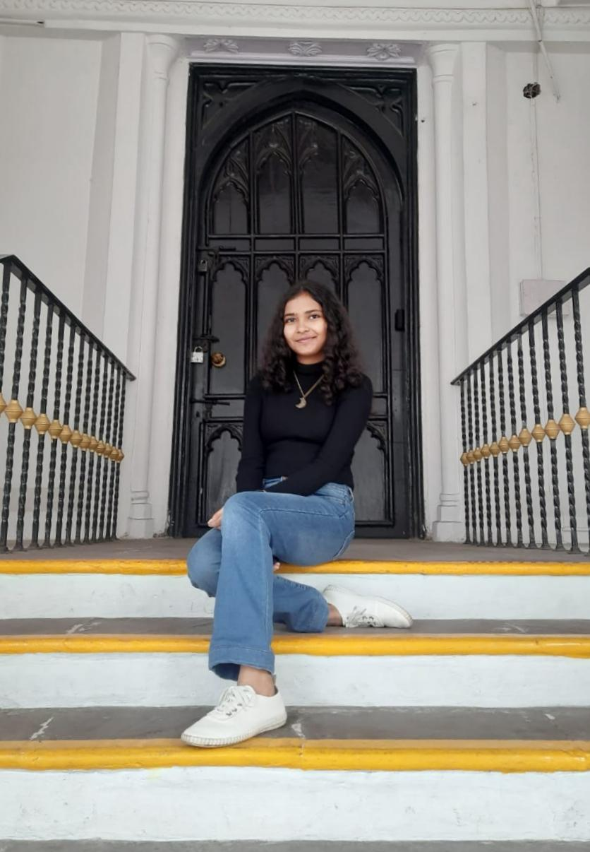

“Always create content that reaches your audience’s audience.”

**Social media and Outreach**

Atharva Deorukhkar

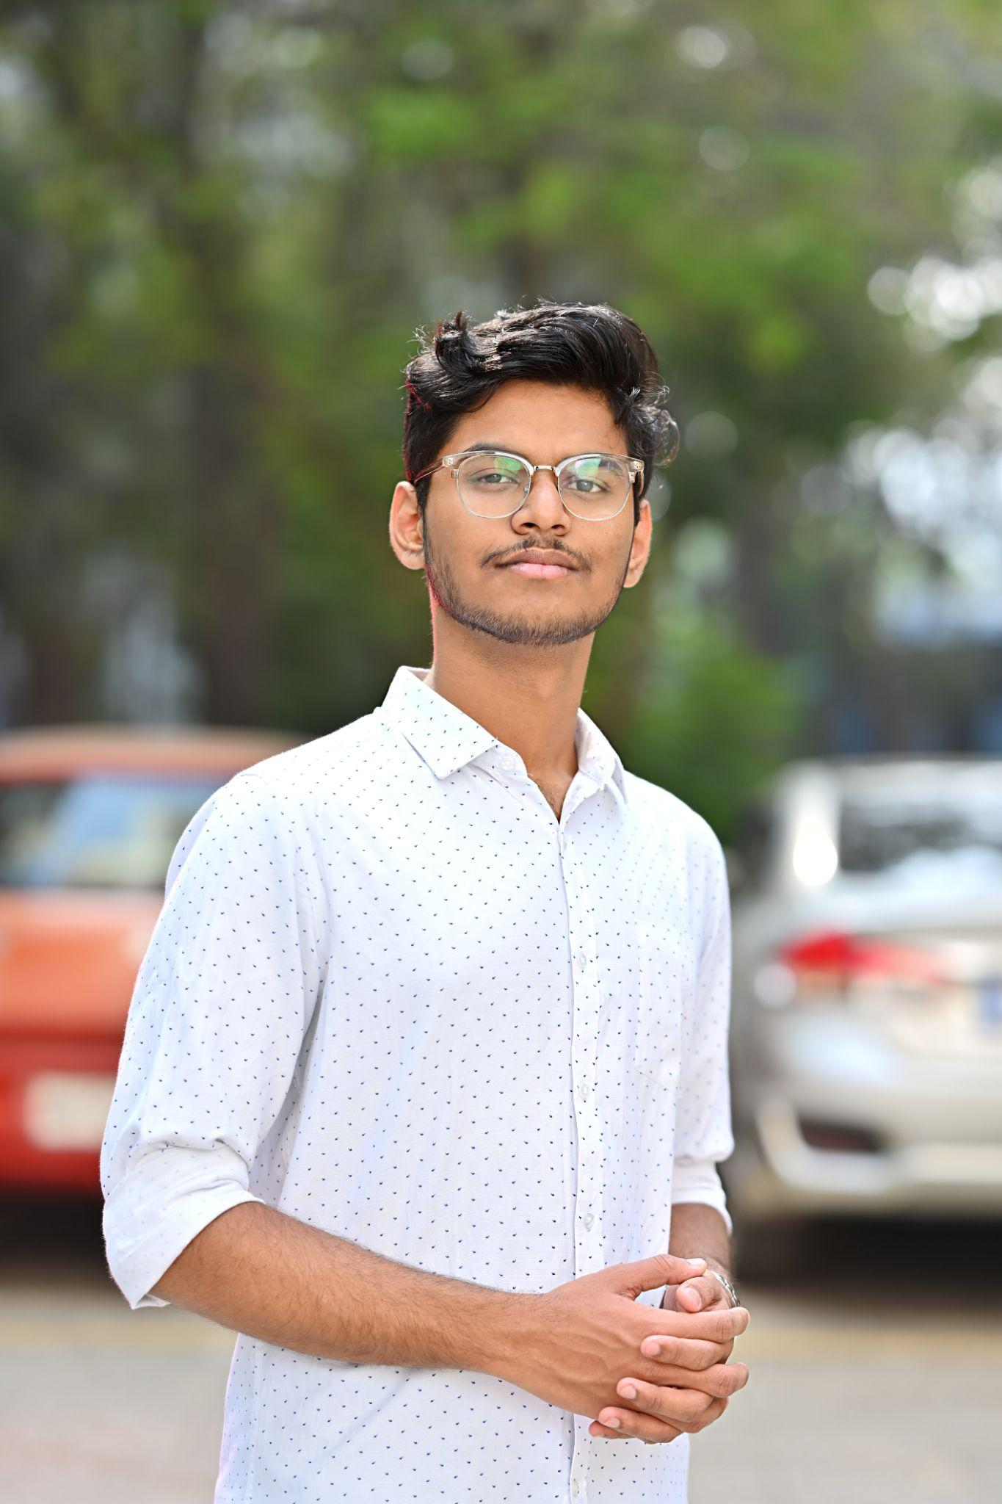

“Social media is not just about creating content, it’s about creating relationships.”

Chirag Gupta

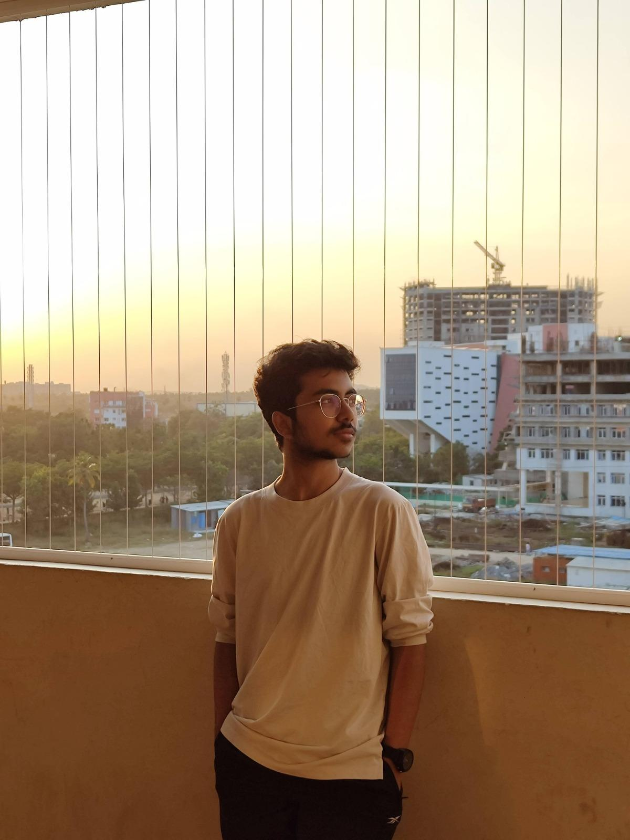

“Don’t wait for some other person or some other time. We are the ones we've been waiting for. We are the change that we seek.”

# **Alumni page**

· about alumni - 2 line short description (general)

Our source of pride and inspiration, our alumni, have taken the mission of the club to their heart and gone to make a positive impact in our community. Through their various endeavours, our alumni have demonstrated their spirit of service and compassion. They continue to be active members of our network,supporting and mentoring their juniors in their pursuits.

· alumni name & photo

· role & period

· contact links - max 3 social media link

1. Dr. Balasundaram A. - Faculty Coordinator

Tenure - 2021 -2022

1. Gaurav Trivedi - President
2. Yuvraj Singh - President
3. Shubham Pandiya - Vice president
4. Akhand Pratap Singh - Vice President
5. Monisha R - Marketing and Management Head
6. Prince Attri - Marketing and Management Head
7. Prince Parnami - Design Head
8. Tanish Mandal - Content Head
9. Saumya Bhardwaj - Social Media and Outreach Head
10. Jaiveer Singh - Social Media and Outreach Head

Tenure - 2022 - 2023

1. Ishika Agarwal - President
2. Aayush Poddar - Vice President
3. Madhumitha S - Marketing and Management Head
4. Shashank Pandey - Marketing and Management Head
5. Aditi Anand - Content Head
6. Naman Grover - Design Head
7. Saanjhi Saraogi - Social Media and Outreach Head

# **Contacts**

· email, phone no. of club

Email - thewhitehelmets.vitc@gmail.com

· all social media links

<https://www.linkedin.com/company/the-white-helmets-vit-chennai/>

<https://www.instagram.com/twh_vitc/>